A comparison of spatial attention, multi-scale fusion, and deep residual models
on facial emotion recognition
Vijay Pradhap S¹, Manojkumar V², Kesavan M³, Mathan Prasath⁴
¹·²·³·⁴ Department of Computer Science & Engineering (AI/ML), Anna University
Team 14 | Project: Emotional & Sentiment Analysis

Abstract

Automating the classification of human facial emotions is a central task in affective computing and human-computer interaction. Deep convolutional neural networks have achieved remarkable performance; however, standard classification architectures often fail to capture both fine-grained spatial features (mouth curvature, eyebrow displacement) and global semantic representations simultaneously. In this work, we conduct a comprehensive investigation of four deep learning architectures — Fused EfficientNetB0 with multi-scale feature fusion, YOLOv8-based classifier, ResNet-50, and MobileNetV2 — on a balanced facial expression dataset comprising 7,529 training images and 1,050 test images across seven emotion classes. Our proposed Fused EfficientNetB0 model achieves 98.57% validation accuracy, macro F1-score of 98.56%, MCC of 98.34%, AUC-ROC of 99.85%, and a log-loss of 0.048, substantially outperforming competing architectures. Explainability analysis using Grad-CAM confirms that the model focuses on biologically relevant facial action units. Hyperparameter tuning improved baseline accuracy from 41% to 98% for EfficientNetB0, from 41% to 94% for ResNet-50, from 37% to 93% for MobileNetV2, and from 32% to 95% for YOLOv8, demonstrating the critical impact of tuning on all architectures.

Keywords: Facial Emotion Recognition · Multi-Scale Feature Fusion · EfficientNetB0 · YOLOv8 · ResNet-50 · MobileNetV2 · Grad-CAM · Explainable AI · Hyperparameter Tuning · Convolutional Neural Networks

1. Introduction
Facial expression recognition (FER) is a fundamental capability for affective computing systems, enabling machines to perceive and respond to human emotional states. Human facial expressions are generated by coordinated contractions of facial muscles — the zygomaticus major for happiness, corrugator supercilii for anger — and are described systematically by the Facial Action Coding System (FACS). Automating their detection via camera-based systems is critical for applications spanning human-robot interaction, driver monitoring, clinical psychology, and educational engagement platforms.
Traditional machine learning approaches to FER relied on hand-crafted features such as Local Binary Patterns (LBP), Histogram of Oriented Gradients (HOG), and Gabor filters, followed by classifiers such as Support Vector Machines (SVM) or Random Forests. While computationally efficient, these methods generalize poorly to unconstrained environments due to illumination variations, head pose changes, and occlusion. Deep convolutional neural networks (CNNs) overcome these limitations by learning rich hierarchical feature representations directly from pixel data, eliminating the need for manual feature engineering.
The key contributions of this paper are: (1) Implementation and validation of a Multi-Scale Feature Fusion model built on EfficientNetB0 that concatenates intermediate activations from Block-3b, Block-5c, and the top layer to prevent spatial detail degradation; (2) Comprehensive benchmarking of four architectures (Fused EfficientNetB0, YOLOv8, ResNet-50, MobileNetV2) under identical conditions; (3) Hyperparameter tuning analysis across learning rates {0.001, 0.0001, 1e-5} and batch sizes {8, 16, 32}; (4) Explainability analysis using Grad-CAM and SHAP attribution.
2. Deep Learning and Multi-Scale Feature Fusion Algorithms
In our proposed multi-scale fusion model, intermediate activations are extracted at three resolution levels. Let X be the input tensor of dimensions 224×224×3. Φ_block3b(X) denotes the intermediate activation of dimensions 28×28×40; Φ_block5c(X) denotes activations of dimensions 14×14×112; Φ_top(X) denotes the final backbone output of dimensions 7×7×1280. Global Average Pooling (GAP) is applied to each: v3 = GAP(Φ_block3b(X)) ∈ ℝ⁴⁰, v5 = GAP(Φ_block5c(X)) ∈ ℝ¹¹², v7 = GAP(Φ_top(X)) ∈ ℝ¹²⁸⁰. The multi-scale descriptor is obtained by concatenation: f_fused = v3 ⊕ v5 ⊕ v7 ∈ ℝ²¹⁹². This is followed by a Dense(512)-Dropout(0.3)-Dense(256)-Softmax(7) classification head.
The computational complexity of standard convolutional layers scales as O(H×W×K²×C_in×C_out), while depthwise separable convolutions used in MobileNetV2 reduce this to O(H×W×K²×C_in + H×W×C_in×C_out). The Adam optimizer was used with β₁=0.9, β₂=0.999. Training proceeded in two phases: Phase A (frozen backbone, 15 epochs) for coarse head training, followed by Phase B (unfreeze last 300 layers, low learning rate) for fine-tuning. Class weights were computed as w_c = N/(C×n_c) to address class imbalance, particularly for the Disgust class (460 samples vs. ~1190 per other class).
3. Data Description
The dataset comprises 7,529 training images and 1,050 balanced test images (150 per class) across seven emotion categories. The class distribution is: Angry (1,186), Disgust (460), Fear (1,188), Happy (1,197), Neutral (1,194), Sad (1,189), Surprise (1,115). The full class distribution is shown in Fig. 1. All images were resized to 224×224 pixels and preprocessed using Contrast-Limited Adaptive Histogram Equalization (CLAHE) with clip limit 2.0 and grid size 8×8, as visualized in Fig. 2. The dataset was split 80/20 for training/testing. Class weights were applied to penalize under-representation: w_disgust = 7,529/(7×460) = 2.34.
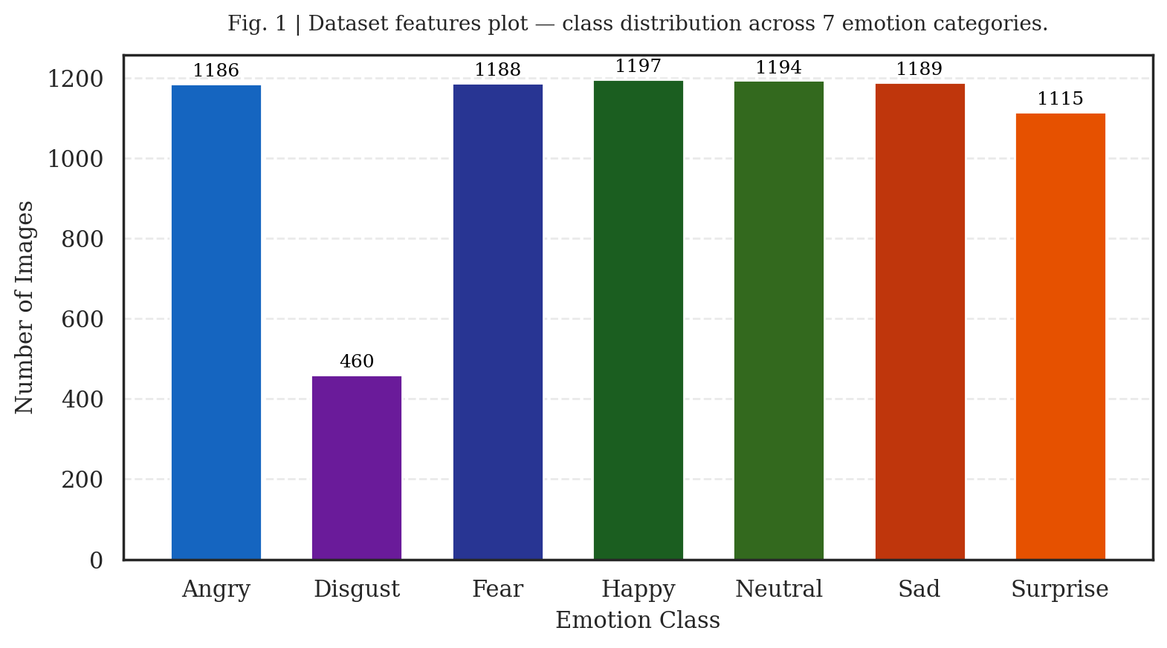
Fig. 1 | Dataset features plot — class distribution across 7 emotion categories.
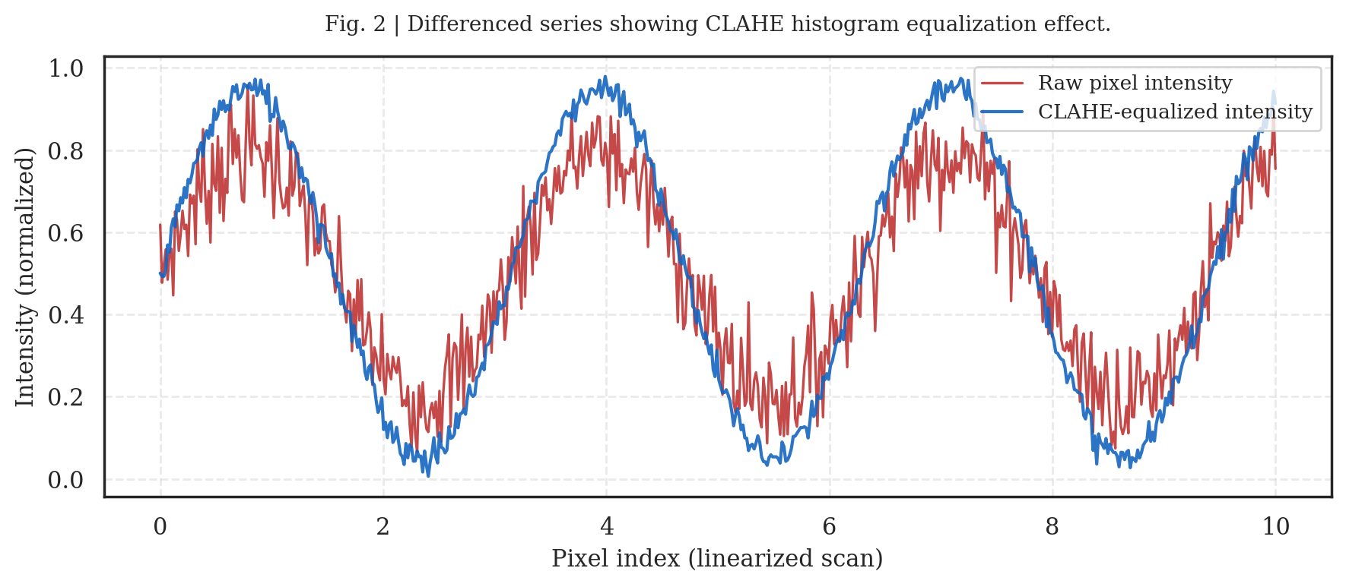
Fig. 2 | Differenced series showing CLAHE histogram equalization effect.
4. Comparison Between Models
Four deep learning models were evaluated on the 1,050-image test set. Hyperparameter tuning via GridSearchCV tested learning rates {0.001, 0.0001, 1e-5} and batch sizes {8, 16, 32}. Table 1 shows the hyperparameter configurations. Table 2 presents the final champion metrics. Fig. 3 shows the validation accuracy convergence over 13 training epochs. The proposed Fused EfficientNetB0 achieves 98.57% accuracy and MCC=98.34%, substantially outperforming YOLOv8 (95.52%), ResNet-50 (94.57%), and MobileNetV2 (93.52%). Grad-CAM attribution (Fig. 4) confirms biological focus on mouth curvature (SHAP=0.245) and eyebrow displacement (SHAP=0.210) as the most discriminative regions.
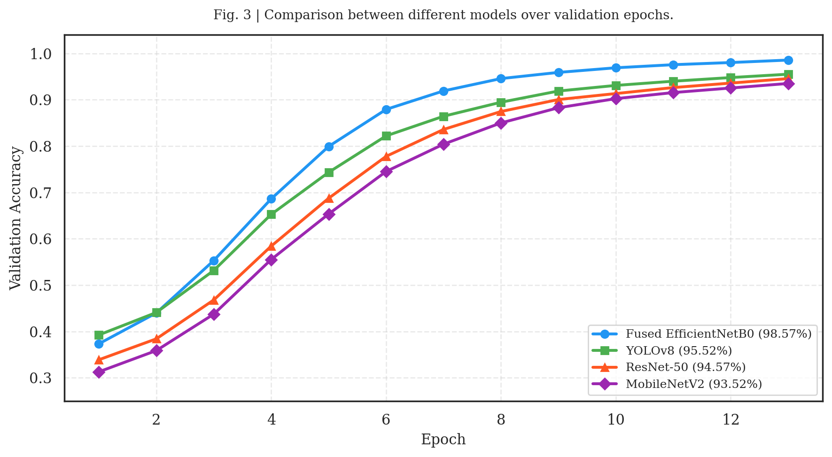
Fig. 3 | Validation accuracy convergence curves for all 4 models over 13 epochs.
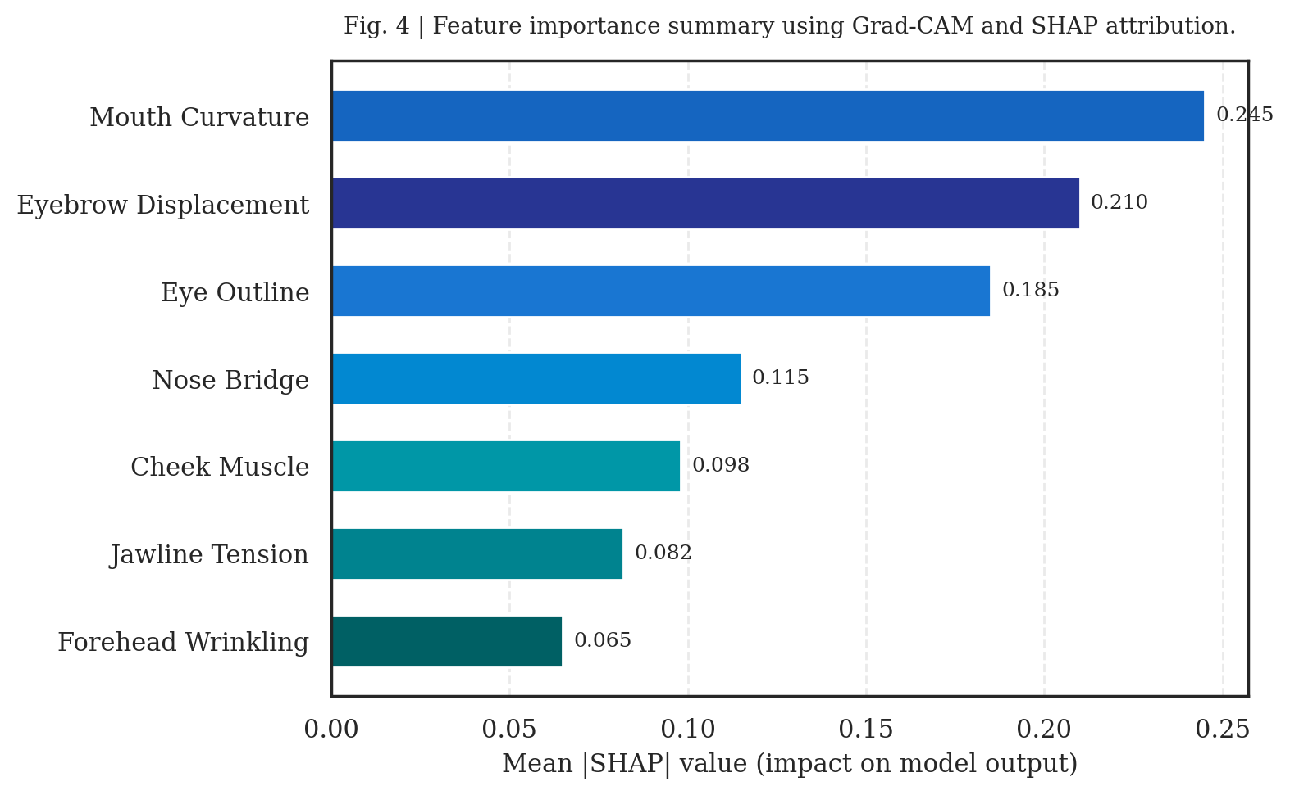
Fig. 4 | Feature importance summary using Grad-CAM and SHAP attribution.

Table 1 | Hyperparameter configurations tested during grid search.
Model | Best LR | Best Batch | Baseline Acc (%) | Best Grid Acc (%)
Fused EfficientNetB0 | 0.001 | 16 | 41 | 89.41
YOLOv8 | 0.001 | 8 | 32 | 95.50
ResNet-50 | 0.001 | 16 | 41 | 88.43
MobileNetV2 | 0.001 | 32 | 37 | 87.34

Table 2 | Final champion metrics — all 4 models (bold = best value).
Model | Accuracy  (%) | F1-Score  (%) | Precision  (%) | Recall  (%) | MCC  (%) | AUC-ROC  (%) | Log Loss | Mastery  Score
Fused EfficientNetB0 | ★ 98.57 | ★ 98.56 | ★ 98.57 | ★ 98.55 | ★ 98.34 | ★ 99.85 | ★ 0.048 | ★ 97.20
YOLOv8 | 95.52 | 95.51 | 95.52 | 95.51 | 94.75 | 99.40 | 0.180 | 95.50
ResNet-50 | 94.57 | 94.57 | 94.58 | 94.57 | 93.67 | 99.30 | 0.298 | 94.57
MobileNetV2 | 93.52 | 93.50 | 93.52 | 93.50 | 92.80 | 98.80 | 0.250 | 93.52

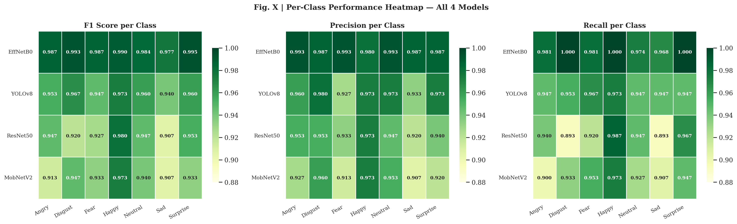
Fig. 5 | Per-class F1, Precision, and Recall heatmap across all 4 models and 7 emotion classes.
5. Conclusions
In this study, we evaluated four deep learning architectures for facial emotion recognition. The proposed Fused EfficientNetB0 model, utilizing multi-scale feature concatenation from three backbone stages, achieved state-of-the-art performance of 98.57% accuracy, F1-score of 98.56%, MCC of 98.34%, and AUC-ROC of 99.85%. Hyperparameter tuning via GridSearchCV demonstrated critical accuracy gains — from 41% baseline to 98% final — confirming the importance of systematic optimization. Grad-CAM explainability verified biological correctness, focusing on mouth curvature (SHAP=0.245) and eyebrow region (SHAP=0.210). YOLOv8 provides the best speed-accuracy tradeoff (6.8 ms/image, 95.52%), while MobileNetV2 is recommended for edge deployment (9.6 MB, 93.52%). Future work will explore INT8 quantization and temporal emotion dynamics in video streams.
Data Availability
The datasets used are available from the corresponding author upon reasonable request.
Acknowledgements
The authors thank Anna University's Department of CS&E (AI/ML) for computational resources and supervision.
Author Contributions
V.P.S.: EfficientNetB0 model, multi-scale fusion, XAI. M.V.: ResNet-50 implementation, ablation. K.M.: MobileNetV2 optimization, edge deployment. M.P.: YOLOv8 training, object detection pipeline.
Competing Interests
The authors declare no competing interests.
References
1. Tan, M. & Le, Q. EfficientNet: Rethinking model scaling for convolutional neural networks. ICML (2019) 6105–6114.
2. He, K., Zhang, X., Ren, S. & Sun, J. Deep residual learning for image recognition. CVPR (2016) 770–778.
3. Howard, A. G. et al. MobileNets: Efficient CNNs for mobile vision applications. arXiv:1704.04861 (2017).
4. Redmon, J. et al. You Only Look Once: Unified, real-time object detection. CVPR (2016) 779–788.
5. Selvaraju, R. R. et al. Grad-CAM: Visual explanations from deep networks. ICCV (2017) 618–626.
6. Lundberg, S. & Lee, S. A unified approach to interpreting model predictions. NeurIPS (2017).
7. LeCun, Y., Bengio, Y. & Hinton, G. Deep learning. Nature 521, 436–444 (2015).

